**Practical 1**

**Question1:**

* Create a Scenario based ER-Models with the entities. (Hospital Details like: Patients, Doctor, test etc)
* Convert this ER-model into table with all the entities. (Minimum five Entities).
* Create table.

**Solution:**

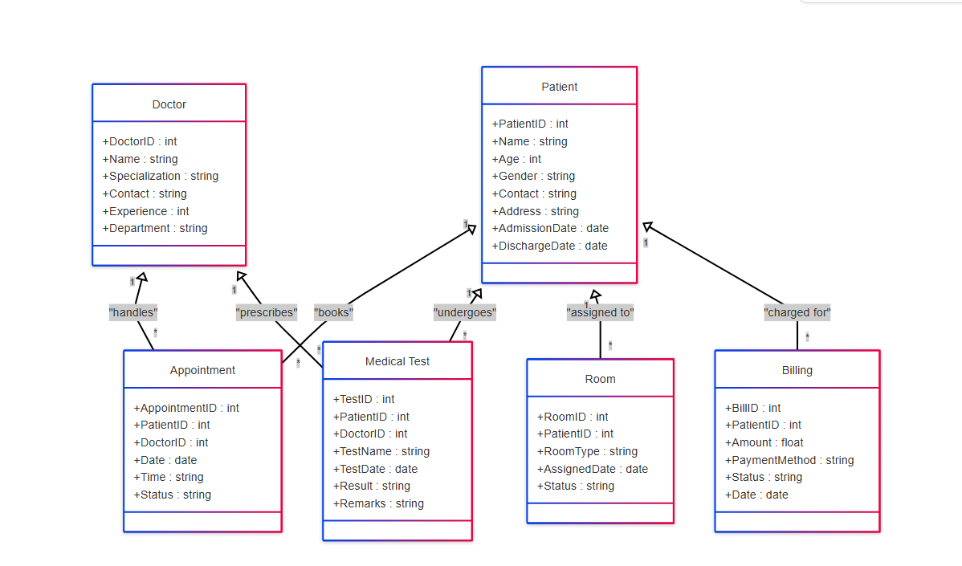

**1. Patient Table**

Stores patient details.

| **Column Name** | **Data Type** | **Constraints** |
| --- | --- | --- |
| PatientID | INT | PRIMARY KEY |
| Name | VARCHAR(100) | NOT NULL |
| Age | INT |  |
| Gender | VARCHAR(10) |  |
| Contact | VARCHAR(15) | UNIQUE |
| Address | TEXT |  |
| AdmissionDate | DATE |  |
| DischargeDate | DATE |  |

**2. Doctor Table (**Stores doctor details.)

| **Column Name** | **Data Type** | **Constraints** |
| --- | --- | --- |
| DoctorID | INT | PRIMARY KEY |
| Name | VARCHAR(100) | NOT NULL |
| Specialization | VARCHAR(100) |  |
| Contact | VARCHAR(15) | UNIQUE |
| Experience | INT |  |
| Department | VARCHAR(100) |  |

**3. Appointment Table (**Manages patient-doctor appointments.)

| **Column Name** | **Data Type** | **Constraints** |
| --- | --- | --- |
| AppointmentID | INT | PRIMARY KEY |
| PatientID | INT | NOT NULL |
| DoctorID | INT | NOT NULL |
| Date | DATE | NOT NULL |
| Time | VARCHAR(10) | NOT NULL |
| Status | VARCHAR(20) | CHECK (Confirmed, Pending, Cancelled) |

**4. Medical Test Table (**Stores test details prescribed by doctors for patients.)

| **Column Name** | **Data Type** | **Constraints** |
| --- | --- | --- |
| TestID | INT | PRIMARY KEY |
| PatientID | INT | NOT NULL |
| DoctorID | INT | NOT NULL |
| TestName | VARCHAR(100) | NOT NULL |
| TestDate | DATE | NOT NULL |
| Result | VARCHAR(100) |  |
| Remarks | TEXT |  |

**5. Room Table (**Manages room assignments for admitted patients.)

| **Column Name** | **Data Type** | **Constraints** |
| --- | --- | --- |
| RoomID | INT | PRIMARY KEY |
| PatientID | INT |  |
| RoomType | VARCHAR(50) | CHECK (General, ICU, Private) |
| AssignedDate | DATE | NOT NULL |
| Status | VARCHAR(20) | CHECK (Occupied, Vacant) |

**6. Billing Table (**Stores billing details for hospital services.)

| **Column Name** | **Data Type** | **Constraints** |
| --- | --- | --- |
| BillID | INT | PRIMARY KEY |
| PatientID | INT | NOT NULL |
| Amount | DECIMAL(10,2) | NOT NULL |
| PaymentMethod | VARCHAR(50) | CHECK (Cash, Credit Card, Insurance) |
| Status | VARCHAR(20) | CHECK (Paid, Unpaid, Pending) |
| Date | DATE | NOT NULL |

**Relationships Summary**

**One-to-Many (1:M)** → **Doctor → Appointments**  
**One-to-Many (1:M)** → **Patient → Appointments**  
**One-to-Many (1:M)** → **Doctor → Medical Tests**  
**One-to-Many (1:M)** → **Patient → Medical Tests**  
**One-to-One (1:1)** → **Patient → Room**  
**One-to-Many (1:M)** → **Patient → Billing**

**Question 2:** Create ER –Diagram for Movie Rental System Movie Rental Informal

**Description**-: The movies are rented out in stores and there are several stores. Each store has a unique distributor that supplies the store with tapes. A distributor may supply more than one store. Each distributor has a name, an address, and a phone number. Each store has a name, an address, and a phone number. For each employee we must keep the following information: working store, a name, a supervisor, an address, a phone number, SIN (social insurance number) and the date when the employee was hired. Foreach customer we must keep the following information: a name, an address, and a phone number (if any). For each rental, we must keep track of which employee served the customer, which movie and which copy (i.e. type) the customer rented, information about payment, the date and the time of the rental, the status (rented, returned_in_time, returned_late), the rate (i.e. the price), and if applicable, due date and overdue charges. About the payment we have to keep which of the employees accepted the payment (does not have to be the same employee who rented the tape), the type of payment (i.e. cash, check, credit card, direct debit – for each type you must provide for relevant information to be kept,e.g. credit card number if credit card is used), the amount of the payment, date + time of the payment, payment status (completed if cash or the money have been received, approved if debit or credit card go through, pending if the check has not cleared yet).About each tape we have to keep information in what condition the tape is and what movie is on the tape. About each movie we must keep its title, director’s name, simple description, the name of a (single) major star, the movie’s rating (use numbers 1-5)

Solution -:

